Name:- Question 1: Implement JWT Authentication in ASP.NET Core Web API

Createing a ASP.NET **named as** JwtAuthExample

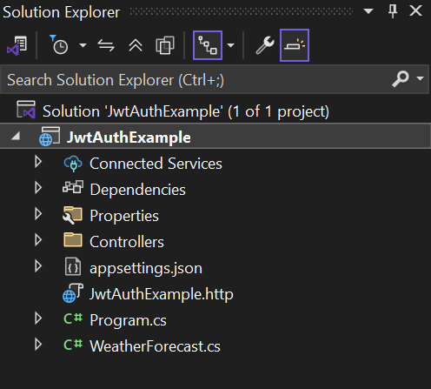

Installing JWT Package

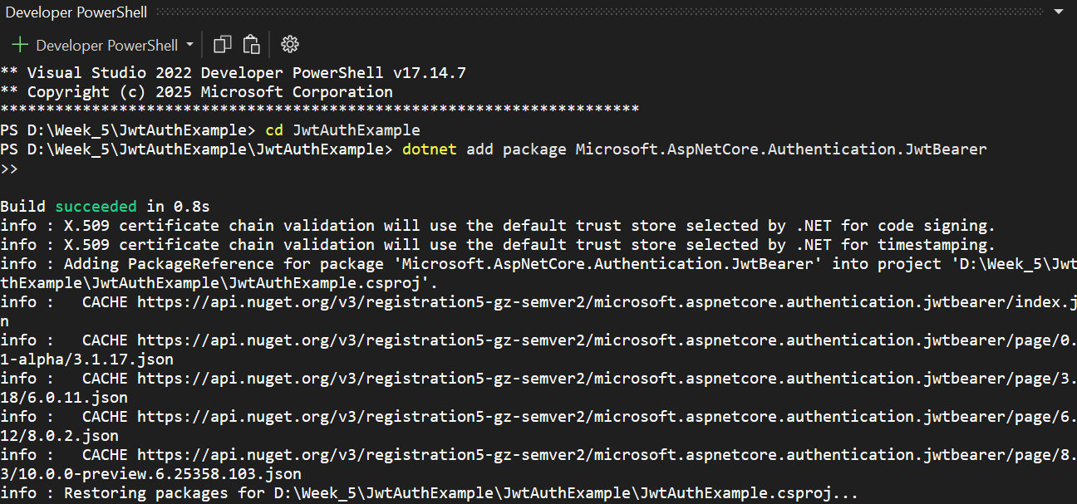

Open appsettings.json and update the code

{

"Logging": {

"LogLevel": {

"Default": "Information",

"Microsoft.AspNetCore": "Warning"

}

},

"AllowedHosts": "*",

"Jwt": {

"Key": "ThisIsASuperSecretJwtKeyThatIsLongEnough@123",

"Issuer": "MyAuthServer",

"Audience": "MyApiUsers",

"DurationInMinutes": 60

}

}

Updated code : Program.cs

using Microsoft.AspNetCore.Authentication.JwtBearer;

using Microsoft.IdentityModel.Tokens;

using Microsoft.OpenApi.Models;

using System.Text;

var builder = WebApplication.CreateBuilder(args);

builder.Services.AddControllers();

var jwtKey = builder.Configuration["Jwt:Key"];

if (string.IsNullOrEmpty(jwtKey))

throw new Exception("JWT key is missing in appsettings.json.");

int byteLength = Encoding.UTF8.GetByteCount(jwtKey);

Console.WriteLine("🔐 JWT Key Byte Length: " + byteLength);

if (byteLength < 32)

throw new Exception("JWT key must be at least 256 bits (32 ASCII characters) long.");

builder.Services.AddAuthentication("Bearer")

.AddJwtBearer("Bearer", options =>

{

options.TokenValidationParameters = new TokenValidationParameters

{

ValidateIssuer = true,

ValidateAudience = true,

ValidateLifetime = true,

ValidateIssuerSigningKey = true,

ValidIssuer = builder.Configuration["Jwt:Issuer"],

ValidAudience = builder.Configuration["Jwt:Audience"],

IssuerSigningKey = new SymmetricSecurityKey(Encoding.UTF8.GetBytes(jwtKey!))

};

});

builder.Services.AddAuthorization();

builder.Services.AddEndpointsApiExplorer();

builder.Services.AddSwaggerGen(c =>

{

c.SwaggerDoc("v1", new OpenApiInfo { Title = "JWT API", Version = "v1" });

c.AddSecurityDefinition("Bearer", new OpenApiSecurityScheme

{

In = ParameterLocation.Header,

Description = "Enter 'Bearer {your JWT token}'",

Name = "Authorization",

Type = SecuritySchemeType.ApiKey

});

c.AddSecurityRequirement(new OpenApiSecurityRequirement

{

{

new OpenApiSecurityScheme

{

Reference = new OpenApiReference

{

Type = ReferenceType.SecurityScheme,

Id = "Bearer"

}

},

Array.Empty<string>()

}

});

});

var app = builder.Build();

app.UseSwagger();

app.UseSwaggerUI(c =>

{

c.SwaggerEndpoint("/swagger/v1/swagger.json", "JWT API v1");

});

app.UseHttpsRedirection();

app.UseAuthentication();

app.UseAuthorization();

app.MapControllers();

app.Run();

Creating a AuthController.cs in Controllers with add controller with Api with Empty Option

using Microsoft.AspNetCore.Mvc;

using Microsoft.IdentityModel.Tokens;

using System.IdentityModel.Tokens.Jwt;

using System.Security.Claims;

using System.Text;

namespace JwtAuthExample.Controllers

{

[ApiController]

[Route("api/[controller]")]

public class AuthController : ControllerBase

{

[HttpPost("login")]

public IActionResult Login([FromBody] LoginModel model)

{

if (model.Username == "admin" && model.Password == "password")

{

var token = GenerateJwtToken(model.Username);

return Ok(new { token });

}

return Unauthorized();

}

private string GenerateJwtToken(string username)

{

var claims = new[]

{

new Claim(ClaimTypes.Name, username)

};

var key = new SymmetricSecurityKey(

Encoding.UTF8.GetBytes("ThisIsASuperSecretJwtKeyThatIsLongEnough@123"));

var creds = new SigningCredentials(key, SecurityAlgorithms.HmacSha256);

var token = new JwtSecurityToken(

issuer: "MyAuthServer",

audience: "MyApiUsers",

claims: claims,

expires: DateTime.Now.AddMinutes(60),

signingCredentials: creds);

return new JwtSecurityTokenHandler().WriteToken(token);

}

}

public class LoginModel

{

public string? Username { get; set; }

public string? Password { get; set; }

}

}

In Controllers folder create a clas TestController.cs

using Microsoft.AspNetCore.Authorization;

using Microsoft.AspNetCore.Mvc;

namespace JwtAuthExample.Controllers

{

[ApiController]

[Route("api/[controller]")]

public class TestController : ControllerBase

{

[HttpGet("public")]

public IActionResult Public() => Ok("Anyone can access this");

[Authorize]

[HttpGet("secure")]

public IActionResult Secure() => Ok($"Welcome {User.Identity.Name}, you are authorized");

}

}

Now Build the Code to check output

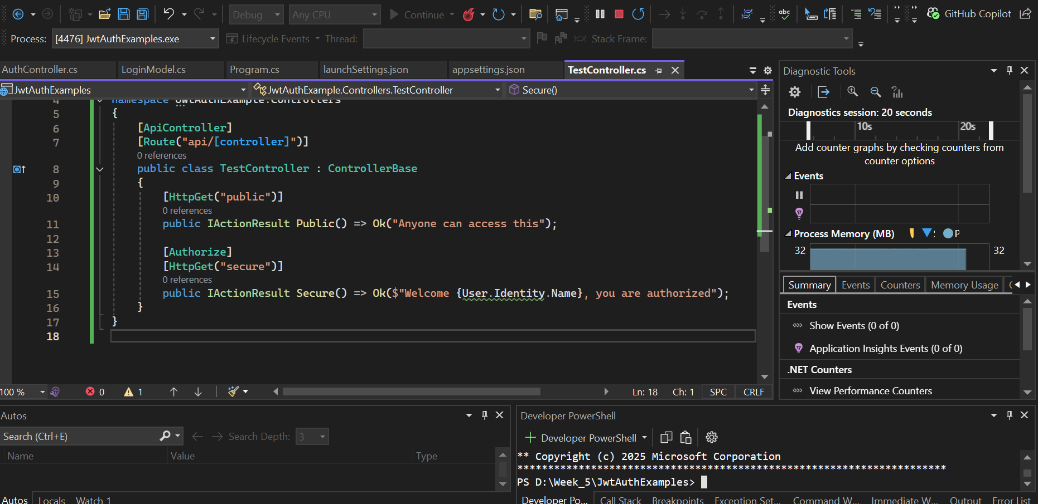

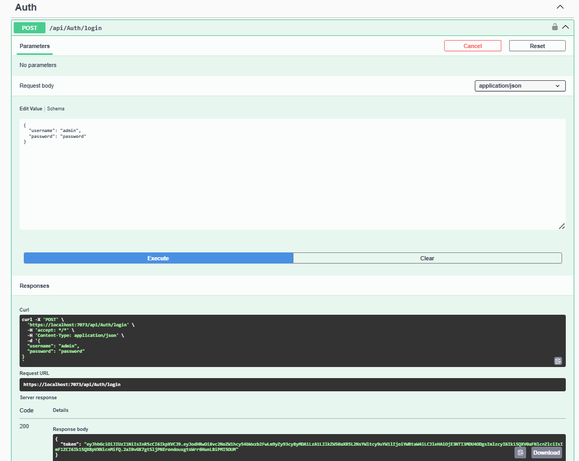

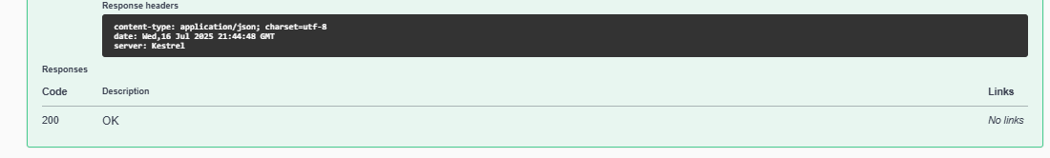

Authorizing Using the Token

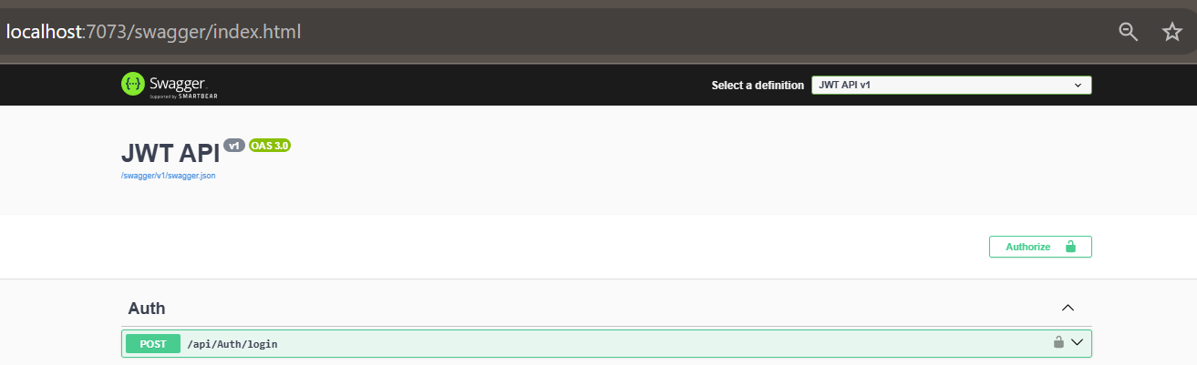

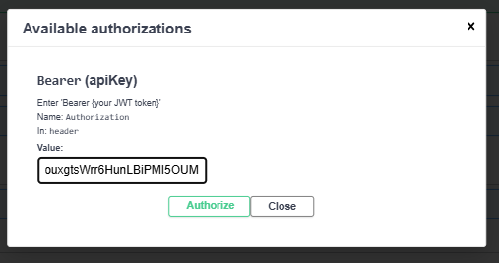

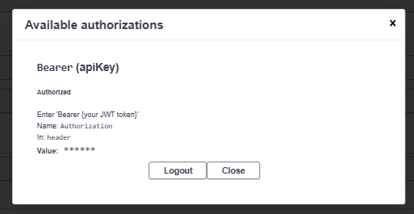

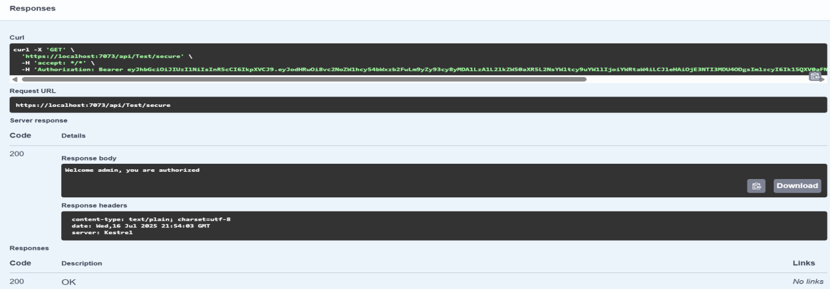

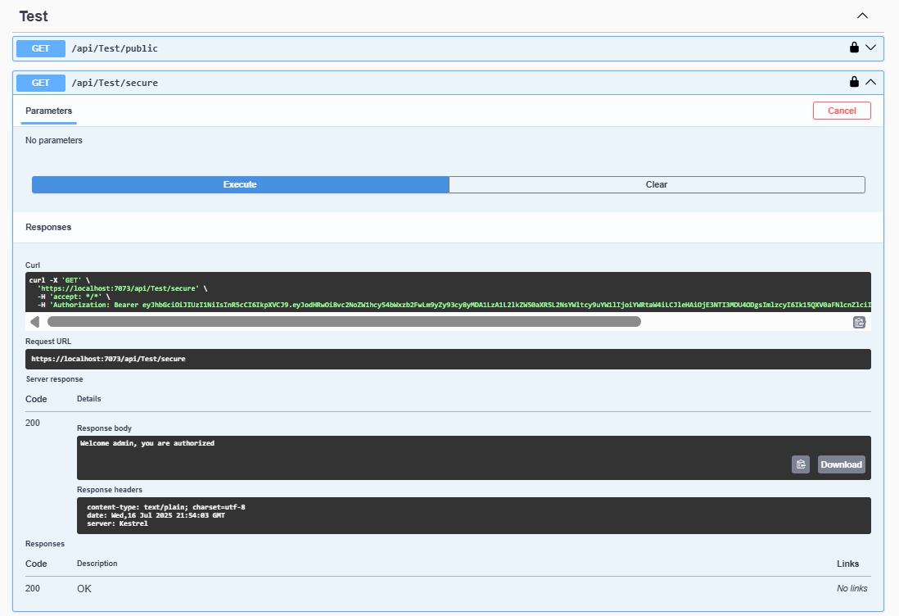

Now Checking output Test the Login Endpoint to Get JWT Token in Postman also

For LOGIN (Token Request) use method Post with URL {

"username": "admin",

"password": "password"

}

